Play Instructions:

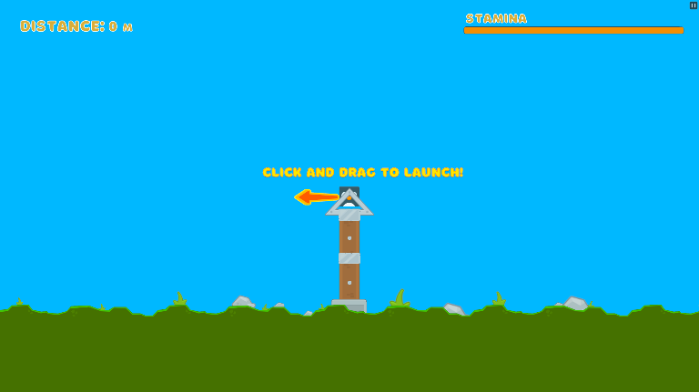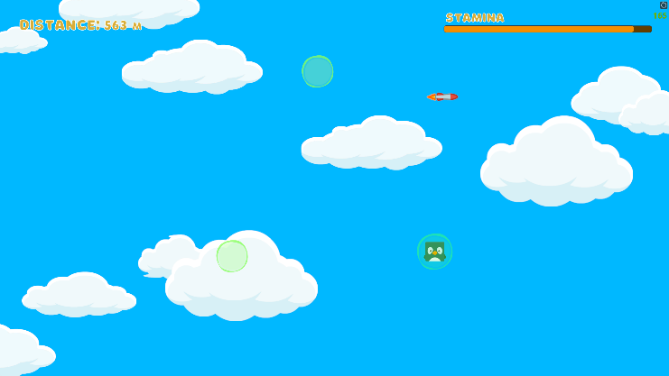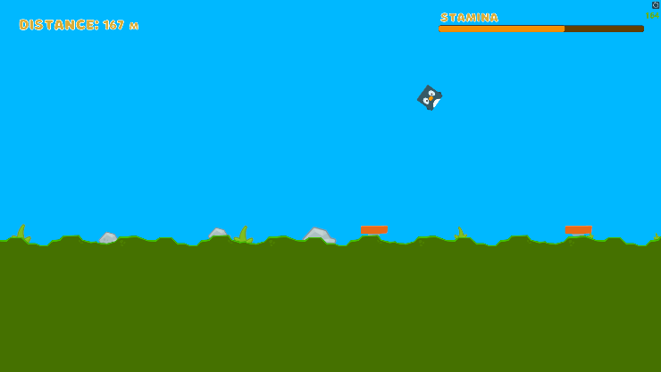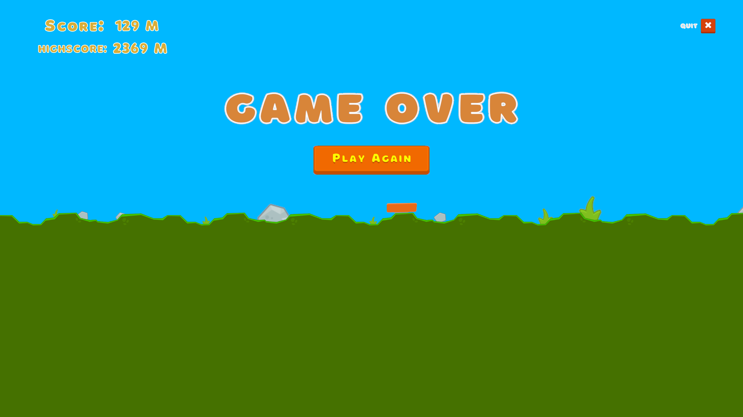

***The game is simple to play!***

*The character is controlled using the* ***Mouse*** *and the* ***Left Mouse Button****.*

***Clicking and dragging*** *the character on the sling shot will adjust the angle and power that you launch with.*

*Once in-flight* ***Clicking anywhere*** *will boost you up and forward!*

*This can be used to adjust your trajectory mid-flight to* ***fly into objects and items*** *which will help extend your flight.*

***Clicking faster*** *will also make you fly faster and higher. But will also deplete your stamina faster.*

*The objects and items you fly into will have a different effect on your flight!*

***Springs*** *will bounce you up,* ***rockets*** *will shoot you forward, and* ***bubbles*** *will prevent you from hitting the ground.*

*The map generated endlessly in a random order as you fly. Some parts have unique attributes.*

*The goal of the game is to fly as far as possible and get the* ***highest score****.*

*The game ends when you* ***hit the ground and stop moving****. Once you touch the ground your stamina stops regenerating and unless you quickly take flight again, its* ***GAME OVER.***